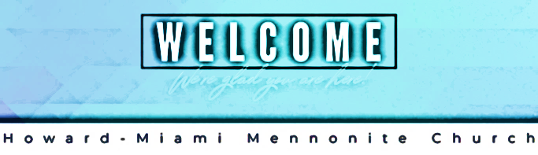
3976 E 1400 S - Kokomo IN 46901 – 765-395-7509
Sunday, December 4, 2022

Howard-Miami Mennonite Church exists to love, glorify and worship God, to love and serve others, to
share the Gospel, and to encourage each other to become fully devoted followers of Jesus, empowered by
The Holy Spirit.

10:00 a.m. Worship: Pre-school & K-5 Jesus and Me: (JAM Basement); Jr. & Sr. High: MYF (North Basement); Adults: Fellowship Hall.

Welcome & Opening Prayer: Don Horner

Song: #191 O Little Town of Bethlehem
#598 A Wonderful Savior is Jesus My Lord

Announcements

Offering and Prayer/Praise Request

Story of Peace: Stanley Miller

Lighting of Peace Advent Candle – Brenda Rogers and Dennis Yoder

Song: #172 O Come, O Come Immanuel

Devotional – Teresa Miller

Song: #336 When Peace like a River

Closing Prayer – Don Horner

Verse of the Week: Peace I leave with you; my peace I give you. I do not give to you as the world gives. Do not let your hearts be troubled and do not be afraid. John 14:27

Prayer:
Pray for those unable to attend: Alma Bontrager, Carol Brubaker, Rosalyn Beachy, Emery Bontrager, Clara Chism, Sadona Lowe. Pauline Rhine, & James Clinton
A celebration of Danny Miller's 90th birthday will take place from 3 to 5 p.m. TODAY Sunday, December 4, here in the fellowship hall. The event will be hosted by Danny and Evelyn's children, Donna, Anita and Keith. All Howard-Miami attenders and community members who know Danny are welcome to attend. No gifts please, though we would be grateful for cards and/or letters with stories about your interactions with Danny over the years.

Dec 10: Women’s Coffee and Conversation 8:30am – 10:30am

Calendar of Events:
Dec 4: Danny Miller’s 90th Birthday!
Dec 7: LTM @ 9am
Dec 10: Women’s Coffee and Conversation
Dec 10: Bethany Blood Drive
Dec 11: Special Christmas Mission Offering

Offering and Attendance
Attendance Last Week: 28
Offering Last Week: $7,635.00
Average Weekly Offering: $3,084.22
Average Weekly Offering Needed: $3,408.90
Offering Year-to-Date: $151,126.86

Office Hours:
Wednesday: 9am – 11am
Thursday: 9am – 11am

Church Email: office@howardmiami.org

